MOTION FORM
FOR
SERVAS INTERNATIONAL GENERAL ASSEMBLY 2022
(SIGA 2022)
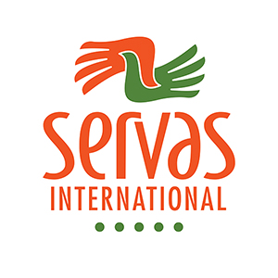
1. Heading for the proposal in this motion (No more than 10 words)

2. Date and place for this motion.

3. SI member group(s) or SI Exco member(s) who is responsible for this motion.
Note that only SI Member Groups or SI Executive Committee (SI Exco, Servas International’s global board) may propose motions for a SIGA.

4. Exact wording of the proposal to be voted on.
We propose that SIGA 2022 approves that (one or more goals and/or actions):
● ...
● …
● …
Please note that SIGA 2022 must be able to vote YES, NO or ABSTAIN on a SIGA proposal.

5. Implications on SI Statutes 2021.
The SI Statutes are accessible on the internet here:
https://servas.org/en/community/board-and-management/administration

Will this proposal affect the SI statutes and therefore create a need for a change in the SI statutes?
If the answer is yes, please:
5A) Copy the part of the SI statutes that you suggest should be amended
5B) Write the exact proposed new wording in the SI Statutes here:

● ….
● …
● …

6. Brief description of the reason for your proposal.
The motivation must contain a clear description of the benefit of this proposal for the Servas community; its member groups, individual members and Servas International as an international non-governmental organisation.
SIGA 2020 should approve this motion because (one or more motivations):
● ….
● …
● …

7. SI budget implications
Describe what financial resources are needed to accomplish the aims of this motion.
Use the money currency Swiss francs, which is the currency used for SI’s budget:

8. Other resources needed –- time, experts with specialist competences or knowledge or other human resources.

9. Proposed timeline/timetable for accomplishing the aims of the proposal?

The proposed action should ideally:
● Start on this date: Year–Month–Day.
● Be accomplished on this date: Year–Month–Day …
● …
The person (s) or group(s) will report the results of this motion to SI Exco.

10. Which person or persons writes/write this motion and is is/are responsible for the proposal?
Name/names:
ServasOnline registration ID/IDs: xxxxx (you find it in your ServasOnline profile on servas.org)

Functions/titles in Servas:

Contact information

Email address/adresses:

Mobile number/numbers (Signal, WhatApp etc):

If applicable:

Other communication channels:

11. Who or which group will be responsible for accomplishing the aim/aims of the proposal in this motion? (SI committee, SI Team, SI member group or Servas individual member/members.

12. SI Exco comment on this motion

Date: 2022-MONTH-DAY
Comment:

For Minute Taker Use Only:
13. Amendments (Passed or defeated)

14. Final Motion (approved or defeated)

