Servas International Peace Riding(SIPR) 2024 along the River Seomjingang, KOREA
- When: April 29th~May 2nd 2024(4days 3nights)
- Main Route: City Jeonju ~ City Gwangyang
- Distance: 220km
- Estimated participants: 40 riders from over 10 countries

Servas Korea would like to invite you to the SIPR 2024 Bike Tour which will be held from April 29th~May 2nd 2024.

We are promoting the experience of ‘Peace Riding’ to share the values of peace and enjoy the beautiful scenery of River Seomjingang focusing on the relationship with Servas members.
This SIPR 2024 Bike Tour is opened to all Servas members who love bike riding and wish to enjoy the sight and feeling of the well-preserved nature and the River Seomjingang.

Let’s meet up at the SIPR 2024 Bike Tour and share great experiences together in wonderful Korea!!

This trip’s route is from City Jeonju to City Gwangyang covering a distance of approximately 220kilometers.

We will be riding bikes approximately 60 ~ 70 km per day.

Cycling along the River Seomjingang course, Dramatic scenery along the picturesque and breathtaking views of the river and farm land

Contacts:
Mr. BW Choi / SIPR 2024 Organizer (bwchoi1211@hanmail.net)
☎ +82 10 5255 0591

Mr. SK Song / Servas Korea National Secretary (sksong@suncheon.ac.kr)
☎ +82 10 8484 2170

BIKE TOUR PROGRAM
Day 1: Monday, April 29th, 2024
: Total 20km(City tour riding)
07:30 Seoul Central Bus Terminal(Bus)~to City Jeonju Express Bus Terminal.
10:00 City bike Tour.
12:30 Lunch(Jeonju style Bibimbap).
(UNESCO City of Gastronomy recognized by the world Taste of Jeonju).
14:00 Check in Jeonju Guest house.
18:00 Dinner(Lee Gawon Korean Restaurant).
Day 2: Tuesday, April 30th, 2024
: Total 75km Riding
08:00 Jeonju Guest house to the lake Okjeongho.
11:00 Seomjingang riding a bicycle towards the first Certification Place.
12:00 Lunch(Local restaurant).
14:00 Kim Yongtaek Poet’s museum of literlature.
17:00 Sunchang Motel stay.
18:00 Dinner(Deodeok bulgogi set).

Day 3: Wednesday, May 1st, 2024
: Total 70km Riding
08:00 Riding.
10:00 Hyangga Amusement Park.
11:00 Saseong Am(Temple Four holy monks).
12:00 Lunch.
14:00 Temple Ssanggyesa.
18:00 Check in Kensington & Dinner.

Day 4: Thursday, May 2nd, 2024
: Total 55km
08:00 Temple Ssanggyesa
09:00 Choi Champan house(traditional Hanok) Pyeongsa-ri,
& Park Kyungri Museum of Literature.
12:00 Island Baeal-do certification place
14:00 Gwnagyang Express Terminal

Route for SIPR 2024

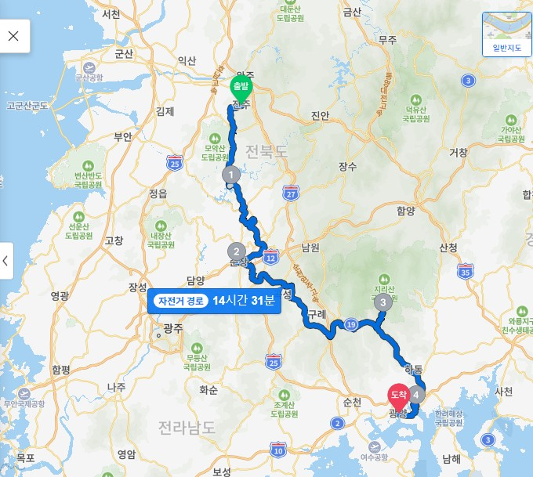
Gunsan
D-4 Gwangyang
D-3 Temple Ssanggyesa
D-2 Sunchang
D-1 Jeonju

# Riders need to bring own bike and safety gears(or can lease bikes and gears in Seoul)
FURTHER DETAILS :

- Participants: 40 Riders.

- If you are not coming with your own bike: the bike rental cost is US$ 15/day & E-bike US$ 30/day. Please specify in the Registration form.

Registration costs (fee):
The fee is USD290(4 days 3 nights) and it has to be paid before the meeting with your payment for SIPR 2024. Your registration will be valid and confirmed only after payment receipt.

Bank Details
Bank Name: KookMin Bank
Bank Add. : 5th FL KookMin bldg. 84 Namdaemun-ro, Jung-Gu, Seoul, Korea
Account No. : 046801 04 161186
Account Name: Servas Korea
Swift code: CZNBKRSEXXX
Fee includes:
- Breakfast, Lunch, Dinners & Snacks
- Accommodation(Youth Hostel or Group accommodation in common)
- Support Car
- Bus fee, Entrance ticket fee
- Round-trip bicycle transpotation.

Fee does not include:
- Bike rental (US$15/day) & E-bike(US$ 30/day)
- Personal insurance
- Additional Event: Discover Korea 2024 Seoul(National gathering meeting).
Accommodation on April 27 th & 28 th – We can arrange Hi Seoul Youth Hostel.
Fee: US$55(2days 1night, 3meals)

Pre-registration form for SIPR 2024

Please complete this form and send it by March 31st, 2024 when you register SIPR 2024 to Mr. BW Choi(bwchoi1211@hanmail.net)

Name and Family Name: ____________________________________________________

Address (street, city, country): _______________________________________________

Phone (include Country code number) Mobile ________________ Home _____________

E mail ______________________________________

Please contact me by… (put an X on the box/boxes) : ( ) Phone ( )E mail

Plan & Accomodation:

( ) Attend only SIPR 2024 Bike tour.
( ) Additional Event Discover Korea 2024 Seoul.
( ) Before & After the SIPR 2024 Bike tour, I ask Servas hospitality:
□ yes, (specify which town) _____________
□ I do not need Servas accommodation (I’ll manage it by myself)

Bike Rental :

If you need to hire a bike, we’ll manage it for you.
In this case, please indicate your height (cm):_____ we will find the bike that suits you better.

Now please check with an “X” one option:
( ) I’m joining the SIPR 2024 bringing with my own bike
( ) I need to rent a bike
( ) I need to rent an e-bike

DECLARATION

(Please sign this declaration, print this paper and take a copy with you at the SIPR)

The "SIPR 2024” organized by Servas Korea is intended as a meeting between friends. The organizers are all volunteers, which mean they are neither guides nor professional tour operators. Each participant is therefore responsible for his/her own safety, and is responsible for any damages caused to her/himself or to third parties. A personal insurance is recommended. Helmet is mandatory.

(Please put an “X” in the box below)

( ) I declare to participate to " SIPR 2024" under my responsibility and I am aware that the organizers and the SERVAS organization does not have any liability-responsibility for any damage or inconvenience that I might cause to others -things or persons- and to myself.

Signature ________________________ date:____________/2024

Good! Thanks for completing this form. Now please send a mail to the organizers (bwchoi1211@hanmail.net) and don’t forget to attach this form.
Remember to print one copy, sign it and bring it with you at the SIPR 2024.
Thanks and see you!!

For further information, feel free to contact the organizers:

Mr. BW Choi / SIPR 2023 Organizer (bwchoi1211@hanmail.net)
☎ +82 10 5255 0591

Mr. SK Song / Servas Korea National Secretary (sksong@suncheon.ac.kr)
☎ +82 10 8484 2170

