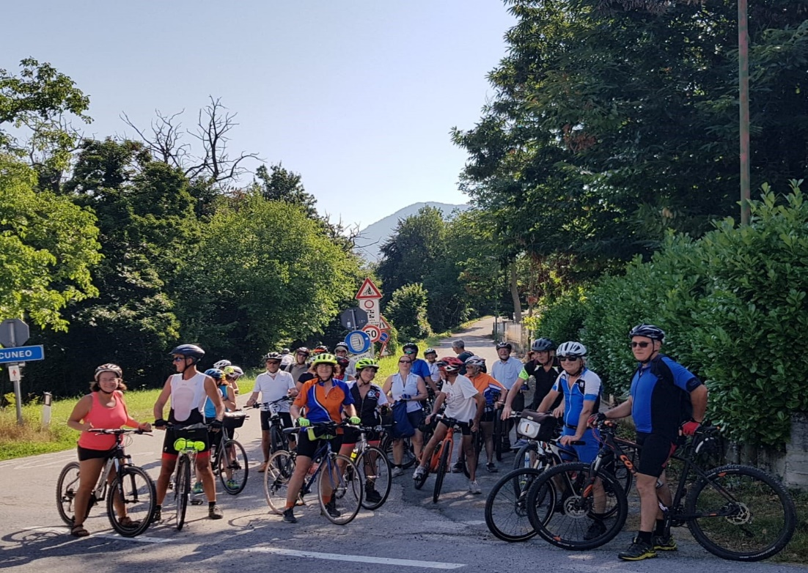
(last Servas bike 2021 in Cuneo, Italy)

SERVAS BY BIKE 23-26 JUNE 2022 –
REGISTRATION FORM

please fill this form to be registered by 10 April 2022, and send by email to Raffaella Rota: rota.raffaella2022@gmail.com (Limited places).

Up to 35 places available for this meeting.

first and last name : ____________________________________________________________

birth place: _____ ______________Nationality:__ _________________

birth date:_____ _________

ID/Pass no:__ ________________________

Address____ ____________________________________ ________________________________

Phone___________________________
E mail __________________________________

I am a Servas memberOpen DoorDay Host

I attach a valid Letter of Introduction 2022: YES  NO, I will send it as soon as possible.

I wish to share the room with: ___________________________________________________________________
___________________________________________________________________

Arrival:
I will arrive at the Hostel on:__ ___________time:_ __________ I will travel with ___________________________________________________________________

Logistic:no. 3 nights: Thursday 23, Friday 24, Saturday 25 (out on Sunday 26)
for 1 person for 3 nights (incl. breakfasts and dinners) CZK 2070/person/3 nights = EUR 85/person, (1 EUR = CZK 24,415.)

Food/allergies:
I inform you that I follow a specific diet or have the following allergies:
________________________________________________________________________________________________________________________________________________________________

Participation fee:

Fee of 2070 CZK (=85 Euro circa to be confirmed as per exchange rate), including what is explained in the program. After our confirmation you will be requested to pay in advance to the Hostel (Iban will follow)

Bicycle :
We suggest you bring your bike.Trekking bike or MTB suggested. Do not forget repair and first aid kits, helmet needed.
If you need to rent a bike, we are hoping to be able to supply bikes and e-bikes so please specify:
 I will bring my own bike
 please book a bike for me
 please book an e-bike for me

I- Covid 19 Declaration (to be signed upon arrival)

Before registration, check the eventual travelling restrictions for your country. Read also the Servas International policy here: https://www.servas.org/en/news/covid-19-host-and-travel-policy-servas
The meeting is organized in compliance with the current Covid 19 regulations. Any changes to the current restrictions will lead to a postponement/cancellation of the meeting itself. It is under your responsibility to check the regulations in your country and eventual travelling restrictions.

II-Release Declaration

The "Servas bike 2022" meeting is to be understood as a meeting of friends. The organizers are all volunteers, they are not professional guides. Helmet is mandatory. Each participant is therefore only responsible for their own safety and the damage it could cause to third parties. You are requested to activate your personal insurance for this event.
(cross “ X “)
I declare to take part to the “Servas Bike 2022” meeting under my responsibility and release the organizers from any responsibilities or damages caused to myself or to third parties.

Signature __ _________________________
date:_ ___________/2022

Please, send this registration form by mail to Raffaella Rota (rota.raffaella2022@gmail.com)
print and bring a copy of this form to the meeting. Please attach your valid Letter of Introduction/LOI. thank you!

The Promoter Servas Group:
Poland (Marietta Milewska,Tony Moult, Michal Olczak)
Czech Rep (Vera Fruhaufova, Pavel Sroubek)
Germany (Conni Geisendorf, Siggi Hilli)
Italy (Raffaella Rota, Gaia Morzenti, Ester Poma)

